CSC501: Module 4 – Project Milestone
11/03/2024
Nathan Rogers

Project Scope
The scope of the project consists of programming a single Fanuc RJ-3000 to move one piece of glass at a time from one conveyor to the other while flipping the glass 180 degrees. To accomplish this project the scope will consist of the following deliverables:
- Teach Pendant programming for the Fanuc Robot program that it will follow in production,
- Safety Lock-Out Tag-Out protocols met with software and hardware guarding,
- IO Programming to handle data transfer from robot to PLC,
- Allen-Bradley programming that will handle the sequencing of conveyor belts, proximity/laser sensors and the IO to and from the robot,
- Electrical engineering for an electrical cabinet to house the new IO terminal blocks, PLC, and any incoming power for the system,
- Systems engineering for integration into the current production line,
- Maintenance and documents about the system for future upkeep,
- Training materials for on-site people
The WBS chart from the last milestone is also a good indicator of project scope which I will include here:
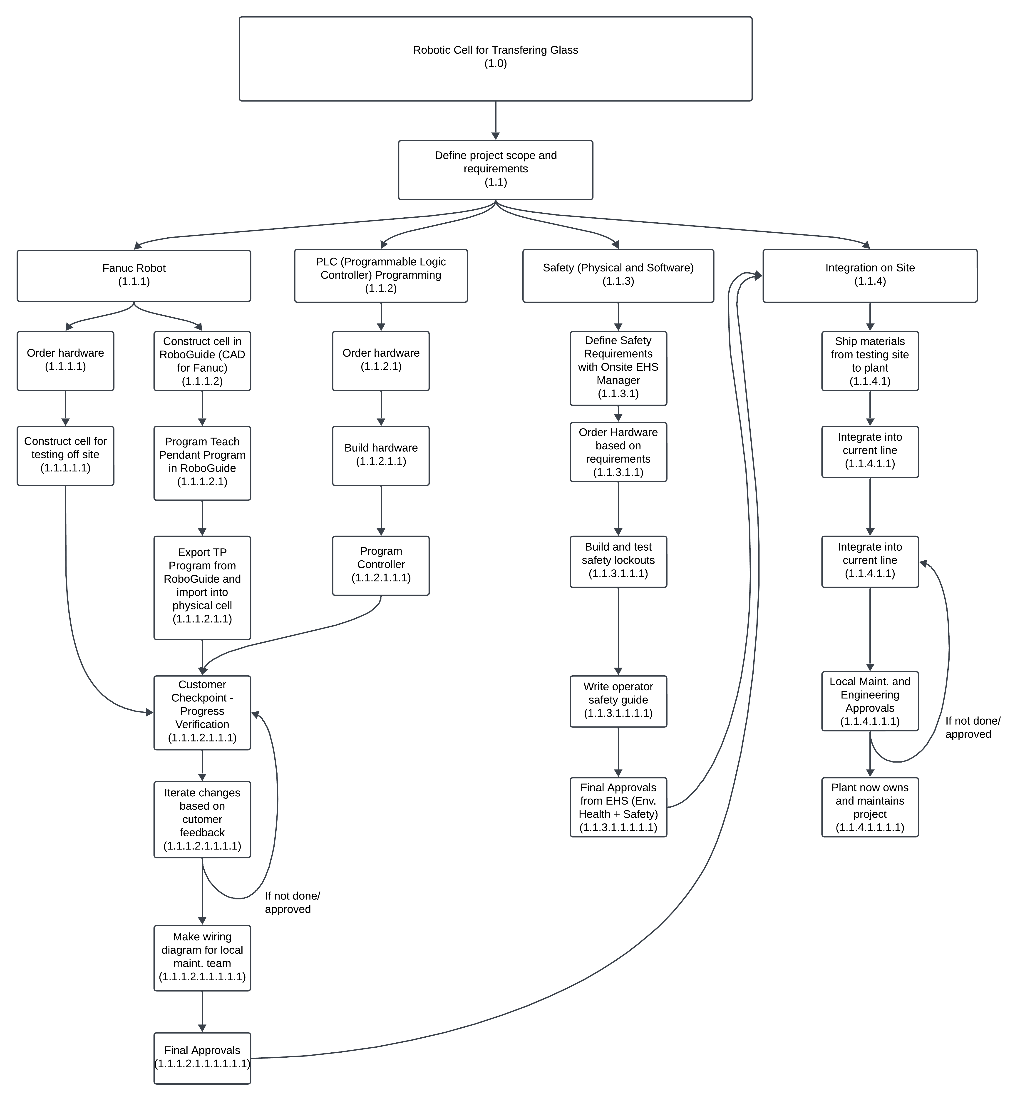

Budget and Timeline
A project such as this will cost at most $250,000, therefore this will be the maximum budget + $30,000 for management/contingency reserves as unknown issues tend to arise towards the end of the project. This includes the robot, all hardware and materials, integrators programming time and installation costs. This does include costs such as paying for the installer’s travel and expenses during the installation phase, and any extra materials necessary for construction.
This Ghantt Chart is a good indication of how long and what deliverables are necessary to complete the project in a timely manner:
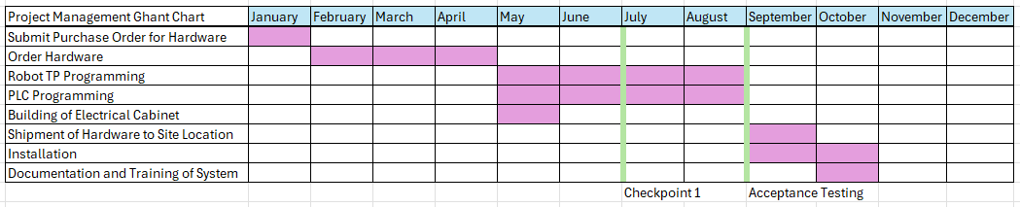
The checkpoint 1 and acceptance testing are chances for both parties, myself and the developers of the robot cell, a chance to align and make sure everything is still on track. It also allows for any changes to be made before being installed on-site. If any changes need to be made, we can adjust the timeline to account for the added time needed to make the change and a formal change request can be submitted which would include the time needed, additional costs, why the change is necessary and who is submitting the change. If any additional funds need to be allocated, then this information will be presented at the gate review for the funds to be released/not released (reserves built into the overall budget).
Stakeholders
Stakeholders in this project will be:
- Myself as the project manager,
- The COO and CEO for making sure the project is worth pursuing and releasing the funds necessary to complete the project,
- The developers making the robot cell,
- On-site engineers and maintenance personnel – To ensure that the line is prepared prior to the cell’s installation, and to ensure the cell can remain in operation without issues once installed
- EHS Manager - to ensure that the operators would be safe while operating the robot cell during normal production
- Production Manager – To ensure that local engineers are well supported after installation
- Plant Manager – To ensure the plant and the production line are going to function as intended after installation.
Not everyone will be actively involved at each stage of the project. People such as the COO and CEO will not need to know every detail, just whether everything is progressing or not progressing and why. Local, on-site people will be involved when it comes to designing the project scope and deliverables and when the project is nearing installation so that they can prepare the line for installation. These engineers will also be responsible for owning, coordinating, and helping with maintaining the system throughout its lifetime. They will be required to report on how the system is functioning and how it is improving the production line (supporting evidence from what was reported during the gate review to get the project approved). People such as managers will need to be informed of any updates and changes but not all details. Finally, as the project manager, I will be involved in every step from purchasing to installation and training.

